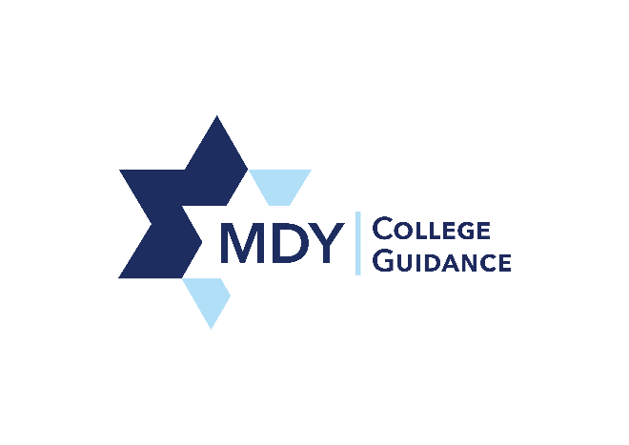

Students’ college acceptances from the past four years (2013-2018) include:

Adelphi University  Babson College  Bar-Ilan  Barnard College  Baruch College  Boston University  Boston College  Brandeis University  Brooklyn College  Center for Allied Health Education (CAHE)  City College of New York  College of Staten Island  Columbia University  Cooper Union  Cornell University  Drexel University  Duke University  Fashion Institute of Technology  Georgetown University  George Washington University  Guttmann Community College | Hofstra University  Hunter College  Indiana University  John Jay College of Criminal Justice  Kingsborough Community College  Lehman College  LIM College  Long Island University  Macaulay Honors College *  Manhattan College  Marymount Manhattan College  Monmouth University  New Jersey Institute of Technology  New York Institute of Technology  New York University  NYC College of Technology  Northeastern University  Northwestern University  Pace University  Parsons  Pennsylvania State University  Pratt Institute | Queens College  Rutgers University  School of Visual Arts  Sophie Davis School of Biomedical Education  SUNY Albany  SUNY Binghamton  SUNY New Paltz  SUNY Stony Brook  Stevens Institute of Technology  St. John’s University  Syracuse University  The New School  Touro College  University of Maryland  University of Massachusetts  University of Miami  University of Michigan  University of Pennsylvania  University of Virginia  Yeshiva University

*Indicates multiple campuses

