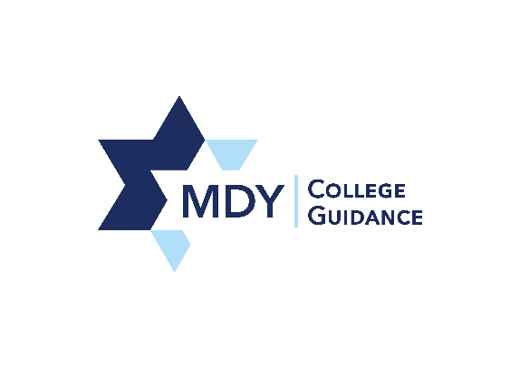

Dear Parents/Guardians and Students:

On Wednesday, October 25, 2017, Magen David Yeshivah High School (MDYHS) will be offering the Preliminary Scholastic Aptitude Test (PSAT). The PSAT is a great practice exam for all student in 9th -11th grades for these reasons:

For Juniors:
- Juniors will begin testing in the spring; if they choose to take the SAT, this is great practice for the real exam.
- Juniors who take the test may qualify to enter the National Merit Scholarship Programs.

For Freshmen, Sophomores, and Juniors:
- The PSAT/NMSQT is a comprehensive tool that gives valuable feedback to the student and the school. Students receive scores in critical reading, math reasoning, and writing.
- The PSAT scores are part of the requirements to take college courses and receive credit in high school.
- It is beneficial to take the test to get a head start on improving academic skills needed for success in college.
- Students receive access to One-Stop College Planning using My College Quick Start, a free online tool, that features valuable resources including:
  - A detailed PSAT/NMSQT score report, including answer explanations & the student’s projected SAT score.
  - A personality test to help students identify their interests and find majors/careers that are a good fit
  - A personalized list of colleges based on the student’s home state and intended major
  - Students who take the PSAT/NMSQT receive free feedback on their aptitude for 20+ AP® courses.
    - Ninth grade students only receive feedback for AP European History and AP World History.

What to Bring on Test Day
- Students should bring #2 pencils (NO MECHANICAL PENCILS) and a calculator.
- Students with disabilities must have a Student Eligibility form on file with the College Board prior to the test date in order to receive appropriate accommodations for the test.
  - Please speak to Ms. Michaels if you have any questions.
- For further details regarding the PSAT/NMSQT, SAT and AP tests, students and parents can visit www.collegeboard.org or speak with a member of the College Guidance team.

Registration will take place from September 12, 2017 – October 3, 2017
- Cost: $20
- Payment will be accepted online via PayPal at http://mdyhs.x10host.com/PSAT%20Fee.html
  - You do not need a PayPal account to register, just a credit card.

Please tear off the permission slip below and staple it to your PayPal receipt of payment. Students should submit both forms stapled together to the designated box in the College Office no later than Tuesday, October 3.

I give my child _______________________________ in grade _______ permission to take the PSAT on Tuesday, October 25, 2017.

Parent/Guardian Name ________________________________________ Date __________________
Phone Number ____________________________

